Book

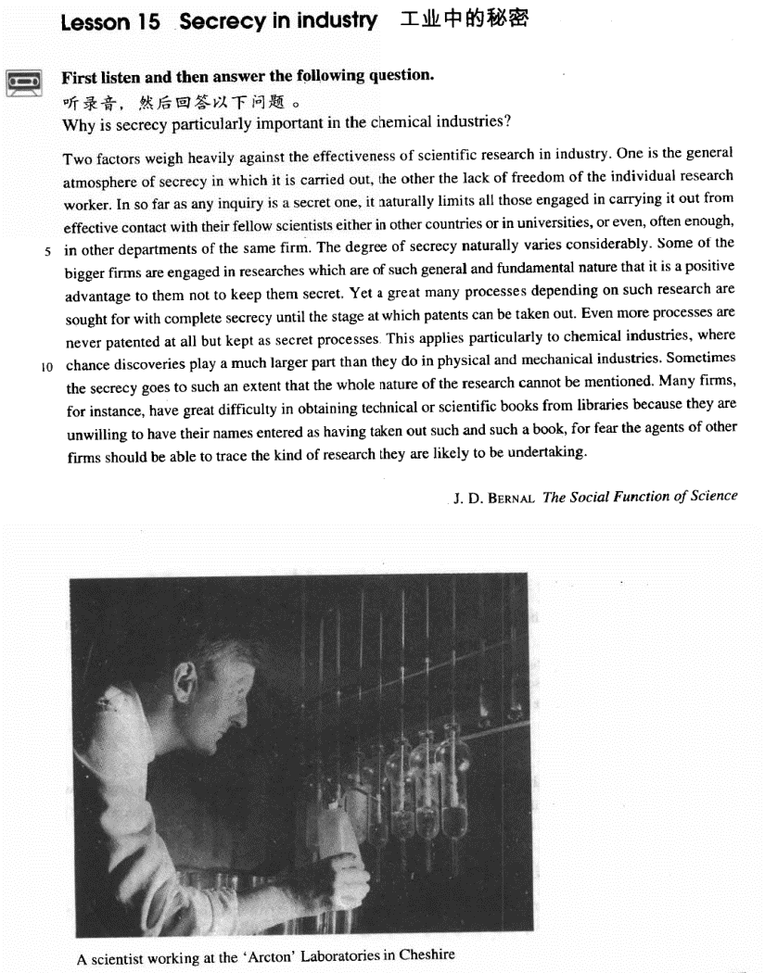

课文

Two factors weigh heavily against the effectiveness of scientific research in industry.

有两个因素严重地妨碍工业中科学研究的效率：

One is the general atmosphere of secrecy in which it is carried out,

一是科研工作中普遍存在的保密气氛；

the other the lack of freedom of the individual research worker.

二是研究人员缺乏个人自由。

In so far as any inquiry is a secret one, it naturally limits all those engaged in carrying it out from effective contact with their fellow scientists either in other countries or in universities,

任何一项研究都涉及到保密，那些从事科研的人员自然受到了限制。他们不能和其他国家、其他大学、

or even, often enough, in other departments of the same firm.

甚至往往不能与本公司的其他部门的同行们进行有效的接触。

The degree of secrecy naturally varies considerably.

保密程度自然差别很大。

Some of the bigger firms are engaged in researches which are of such general and fundamental nature that it is a positive advantage to them not to keep them secret.

某些大公司进行的研究属于一般和基础的研究，因此不保密对他们才有利。

Yet a great many processes depending on such research are sought for with complete secrecy until the stage at which patents can be taken out.

然而，依赖这种研究的很多工艺程序是在完全保密的情况下进行的，直到可以取得专利权的阶段为止。

Even more processes are never patented at all but kept as secret processes.

更多的工艺过程根本就不会取得专利权，而是作为秘方保存着。

This applies particularly to chemical industries, where chance discoveries play a much larger part than they do in physical and mechanical industries.

在这化学工业方面尤为突出。同物理和机械工业相比，化学工业中偶然发现的机会要多得多。

Sometimes the secrecy goes to such an extent that the whole nature of the research cannot be mentioned.

有时，保密竟达到了这样的程度，即连研究工作的整个性质都不准提及。

Many firms, for instance have great difficulty in obtaining technical or scientific books from libraries because they are unwilling to have their names entered as having taken out such and such a book,

比如，很多公司向图书馆借阅科技书籍时感到困难，因为它们不愿让人家记下它们公司的名字和借阅的某一本书。

for fear the agents of other firms should be able to trace the kind of research they are likely to be undertaking.

他们生怕别的公司的情报人员据此摸到他们可能要从事的某项科研项目。

词汇讲解

Lesson 15 Secrecy in industry

secrecy ['si:krəsi]

n. 保密

secrecy n. keeping secrets, or state of being secret in secrecy / in secret / secretly

Many civilians were slaughtered and buried in secrecy / in secret / secretly.

in the secrecy of one’s heart

The personable young man is Mary’s true love in the secrecy of her heart. be veiled / shrouded / cloaked in secrecy

The president’s exact itinerary was veiled / shrouded / cloaked in secrecy for security reasons.

effectiveness [ɪ7fek'tɪvnɪs]

n. 有效，见效

effective

take effective action / measures / steps … a very effective ruler

effectual

take effectual measures √ an effectual ruler X efficacious

an efficacious medicine

Vaccination is efficacious in preventing smallpox.

efficient

efficient methods

an efficient secretary inquiry [in'kwaiəri]

n. 询问，查询；调查，研究

inquiry / enquiry ~ desk inquiry inquisition

investigation inquest

research

inquiry on the spot inquiry

official inquiry sampling inquiry inquisition

The suspect was pushed toward the edge by the inquisitions of the police. investigation

The case is *under* investigation.

The investigation *into* the cause of the air crash is continuing. inquest

an inquest *into* the death of the actor research

scientific research process

['prəʊses] ['prɑsɛs]

n. 过程，进程，步骤； 制作方法，工艺流程

process: n. 1. a series of actions that are done in order to achieve a result

过程，进程，步骤 the process of aging the process of digestion

the Middle East peace process

process n. 2. method in industry to make sth. 工业上制做某种产品的方法，工艺流程

They have developed a new process for extracting aluminum from bauxite.

in the process of doing sth.

We’re still in the process of moving house. process v. 加工，处理

central processing unit (CPU)

data processing weigh one’s words

weigh the pros and cons

We must weigh the pros and cons before deciding whether to invest our money.

weigh with sb.

It weighs heavily with me. It matters to me.

It means a lot to me.

It makes a lot of difference to me. weigh in one’s favor

These facts will weigh in your favor. weigh against …

The lady’s evidence will weigh against him. I’m not optimistic about the verdict.

One is the general atmosphere of secrecy in which it is carried out, *the*

*other the lack of freedom of the individual research worker*.

atmosphere n. the mood or feeling that exists in a place and affects the people who are there 气氛

After Joe left there was a more relaxed atmosphere at home.

atmosphere of …

There is an atmosphere of tension in the city today.

One is the general atmosphere of secrecy in which it is carried out, the

other (being) the lack of freedom of the individual research worker.

In so far as any inquiry is a secret one, it naturally limits all those

*engaged in carrying it out* from effective contact *with their fellow*

*scientists either in other countries or in universities, or even, often*

*enough, in other departments of the same firm*.

in so far as … / insofar as …

= to the extent that …

She cites other scholars’ work only insofar as it supports her own theories.

= because / since / in that

He can be trusted insofar as he has never told a lie. limit … from …

His wife keeps him from alcohol.

The problem barred / prevented me from completing the work. I dissuaded him from committing suicide.

prohibit … from … ban … from … disqualify … from …

His criminal record disqualifies him from serving on a jury. save / rescue … from …

restrain … from …

Please restrain yourself from coughing during the performance. keep in contact with sb.

keep in touch with sb.

Please don’t hesitate to contact with me if you have further questions. X Please don’t hesitate to contact me if you have further questions. √

vary greatly / widely / significantly / dramatically / enormously / substantially

vary slightly / somewhat

vary in size / degree / length …

Rooms vary in size but all have television and telephone. vary according to …

The leaf's size varies widely according to the area where it grows.

Every solid object will reflect a sound, varying according to the size and nature of the object.

vary from … to …

Tests scores vary from school to school.

The amount of sleep we need varies from person to person.

Office hours vary from company to company and country to country. Some of the bigger firms are engaged in researches which are of such

general and fundamental nature *that it is a positive advantage to them not*

*to keep them secret*.

of … nature

of the most perilous nature treaties of a political nature

questions of an academic nature articles of a technical nature

… which are *so* general and fundamental *that* it is …

… it is in their best interests not to …

… to keep them open (to the public).

Yet a great many processes depending on such research are sought for with complete secrecy until the stage *at which patents can be taken out*. research [U] / researches [pl.]

a research X two researches X

a study √ two studies √

seek

seek refuge / shelter / asylum

seek revenge seek comfort seek for / after …

seek for solutions

His book is much sought after. take out a patent

apply for a patent give / grant a patent infringe a patent

… until they own the intellectual property rights.

This applies particularly to chemical industries, where chance discoveries

play a much larger part *than they do in physical and mechanical*

*industries*. apply to …

The rules of safe driving apply to everyone.

The restriction no longer applies to him because he is over 18. chance adj. accidental

a chance meeting / encounter

deliberate intentional

chance / happen to do

He chanced / happened to be out when I called him. as chance would have it

as luck would have it play a … role / part in …

Legend has it that the antibiotic penicillin is a chance discovery by British bacteriologist Sir Alexander Fleming.

If I have ever made any valuable discoveries, it has been owing more to patient observation than to any other reason.

— Isaac Newton, English physicist

Sometimes the secrecy goes to such an extent that the whole nature of the

research cannot be mentioned.

Many firms, *for instance*, have great difficulty in obtaining technical or

scientific books from libraries because they are unwilling to have their names entered as having taken out such and such a book, *for fear the agents of other firms should be able to trace the kind of research they are*

*likely to be undertaking*. have difficulty (in) doing sth. have trouble (in) doing sth. have a hard time doing sth.

She had a hard time writing the dear John letter. be hard pressed to do sth.

Although negotiators are optimistic, the details are complex enough that they may be hard-pressed to get a deal at all.

be unwilling to do sth. be reluctant to do sth.

Though he was reluctant to do so at first, we eventually persuaded him to take us.

be disinclined to do sth.

I was disinclined to talk to him about it. be indisposed to do sth.

He seemed somewhat indisposed to depart. be willing to do sth.

be ready / prepared to do sth.

be inclined to do sth. be disposed to do sth.

take out 1. borrow books from a library You can take out six books at a time. take out 2. obtain an official document

take out an insurance policy / a mortgage / a patent

They find a house, agree a price, and take out a mortgage. such and such a person

such and such a place for fear (that) …

in case (that) …

I daren’t tell you what he did, for fear that he should be angry with me.